# Windows - Eclipse IDE Installer

The Eclipse installer automates the installation of Eclipse development environment.

Download the Eclipse windows installer from the following link: <https://www.eclipse.org/downloads/packages/installer>.

**Note**: This document currently includes information supporting Eclipse IDE Version: 2021-12 (4.22). However, Eclipse IDE Version of 2023-06 (4.28) or lower can be installed..

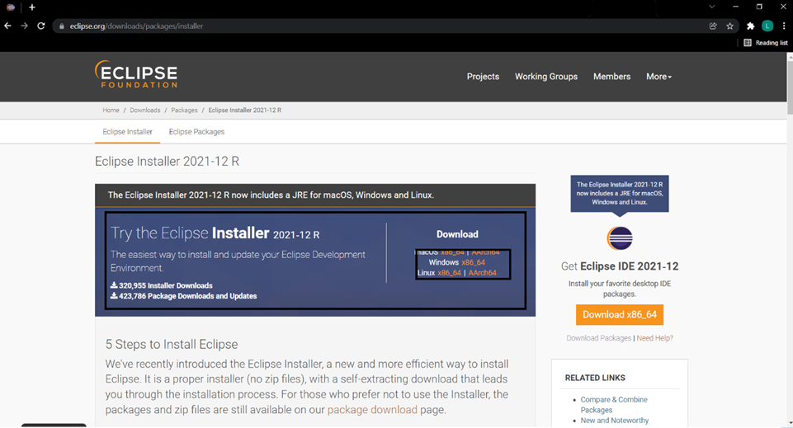

Figure 10: Windows-Eclipse IDE installer